**Digital Naturalist AI enabled tool for Biodiversity researchers**

**Project Report**

**Team ID : PNT2022TMID51328**

**Team Size : 4**

**Team Members :**

**Team Leader : BABIN NIVYA P**

**Team member : ABIMITHA V**

**Team member : ABISHA G**

**Team member : VIGNESH S K**

1. **INTRODUCTION**

1. Project Overview

2. Purpose

2. **LITERATURE SURVEY**

1. Existing problem

2. References

3. Problem Statement Definition

3. **IDEATION & PROPOSED SOLUTION**

1. Empathy Map Canvas

2. Ideation & Brainstorming

3. Proposed Solution

4. Problem Solution fit

4. **REQUIREMENT ANALYSIS**

1. Functional requirement

2. Non-Functional requirements

5. **PROJECT DESIGN**

1. Data Flow Diagrams

2. Solution & Technical Architecture

3. User Stories

6. **PROJECT PLANNING & SCHEDULING**

1. Sprint Planning & Estimation

2. Sprint Delivery Schedule

3. Reports from JIRA

7. **CODING & SOLUTIONING**

1. Dashboard

2. Report and Story

3. Creating the Web App

8. **RESULTS**

1. Performance Metrics

9. **ADVANTAGES & DISADVANTAGES**

10. **CONCLUSION**

11. **FUTURE SCOPE**

?? **PROJECT DESCRIPTION**

A naturalist is someone who studies the patterns of nature, identifies a different kind of flora and fauna in nature.Being able to identify the flora and fauna around us often leads to an interest in protecting wild spaces, and collecting and sharing information about the species we see on our travels is very useful for conservation groups like NCC.

When venturing into the woods, field naturalists usually rely on common approaches like always carrying a guidebook around everywhere or seeking help from experienced ornithologists. There should be a handy tool for them to capture, identify and share the beauty to the outside world.

Field naturalists can only use this web app from anywhere to identify the birds, flowers, mammals and other species they see on their hikes, canoe trips and other excursions.

In this project, we are creating a web application which uses a deep learning model, trained on different species of birds, flowers and mammals (2 subclasses in each for a quick understanding)and get the prediction of the bird when an image is been given.

**Purpose:**

This Project aims to identify a species in a forest or in any other place, we need to carry a heavy book orseek a professional like botanist or zoologist or an ornithologist, but there should be a handy tool for themto capture, identify and share the beauty to the outside world.

**LITERATURE SURVEY**:-

**Existing problem**

There is a need to carry a guidebook around every time we leave for a biodiversity reserve to identify itsorganisms. Internet databases does not have a easier method to search through them and we need tomanually go through them but using ai and advanced ml algorithms we can improve this problem

**PAPER-1**

Plant Species Recognition Using Morphological Features and Adaptive Boosting Methodology (2019).

**Authors:** MUNISH KUMAR, SURBHI GUPTA, XIAO-ZHI GAO AND AMITOJ SINGH

The paper uses a novel plant species classifier that recognizes the plant species in the image. Out of many

features, leaf shape is a conspicuous element that most algorithms rely on to perceive and describe a plant. The system extracts the morphological features of the plant leaf and classifies using Multilayer Perceptron and otherclassification algorithm along with AdaBoost methodology. Different classifiers, i.e., KNN, Decision Tree and Multilayer perceptron are employed to test the accuracy of the algorithm. The authors have observed that the maximum precision rate of 95.42% has been achieved for 32 kinds of plant leaves and the proposed system hasperformed better than the existing techniques for plant leaf recognition.

**PAPER-2**

Ungulate Detection and Species Classification from Camera Trap Images Using RetinaNet and Faster R-

CNN (2022)

Authors: Gholamreza Anbarjafari, Ilja Pavlovs, Kadir Aktas ,Egils Avots, Jevgenijs Filipovs, Agris Brauns, Gundega Done, Dainis Jakovels, Gholamreza AnbarjafariThis paper presents a new dataset of wild ungulates which was collected in Latvia. It demonstrate two methods, which use RetinaNet and Faster R-CNN as backbones respectively, to detect the animals in the images. Faster R-CNN–ResNet50 network and RetinaNet were trained for 34,850 iterations (10 epochs) on the training dataset with a batch size of 4, learning rate of 0.0001 and Adam optimizer for the weight update. The general structure of the detector involves image embedding, object localization and classification. DNN consisting of convolutional layers which are used for the feature extraction from the input image. Usually, backbone networks which are pretrained on a natural image dataset such as ImageNet are used. Common networks used as the backbone are ResNet50, VGG160, Inception-ResNetV2 and DarkNet-19. The neck network takes and processes inputs from the differentlayers of the backbone, harnessing advantages of data pattern distribution over different feature map scalesby using FPN (Feature Pyramid Network). A feed-forward neural network which performs the classification or regression task.

**PAPER-3**

Species determination using AI machine-learning algorithms: Hebeloma as a case study.

Authors: Peter Bartlett1et

In this paper, Peter Bartlett1et al (2022) proposed the work related to the species determination using AI and machine learning algorithms. They used the Hebeloma species as a case study and found that any species with sufficient datasets will find the best algorithm for processing it. The species identifier was able to identify 77% correctly with its highest probabilistic match, 96% within its three most likely determinations and over 99% of collections within its five most likely determinations. Each hidden layer has an activation function of either Rectified Linear Unit (ReLU) or Mish.

EMPATHY MAP:

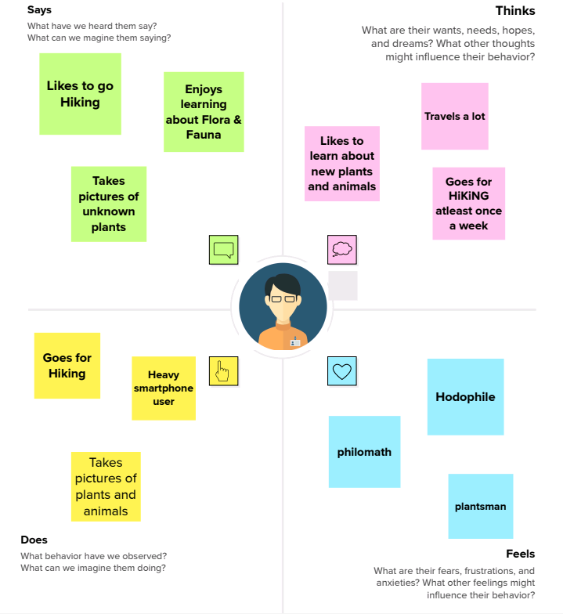

:

**Ideation Phase**

**Brainstorm & Idea Prioritization Template**

**Step-1: Team Gathering, Collaboration and Select the Problem Statement Step-2: Brainstorm, Idea Listing and Grouping**

**Step-3: Idea Prioritization**

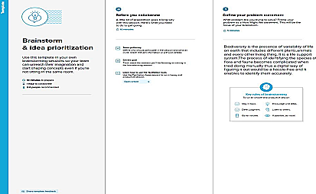

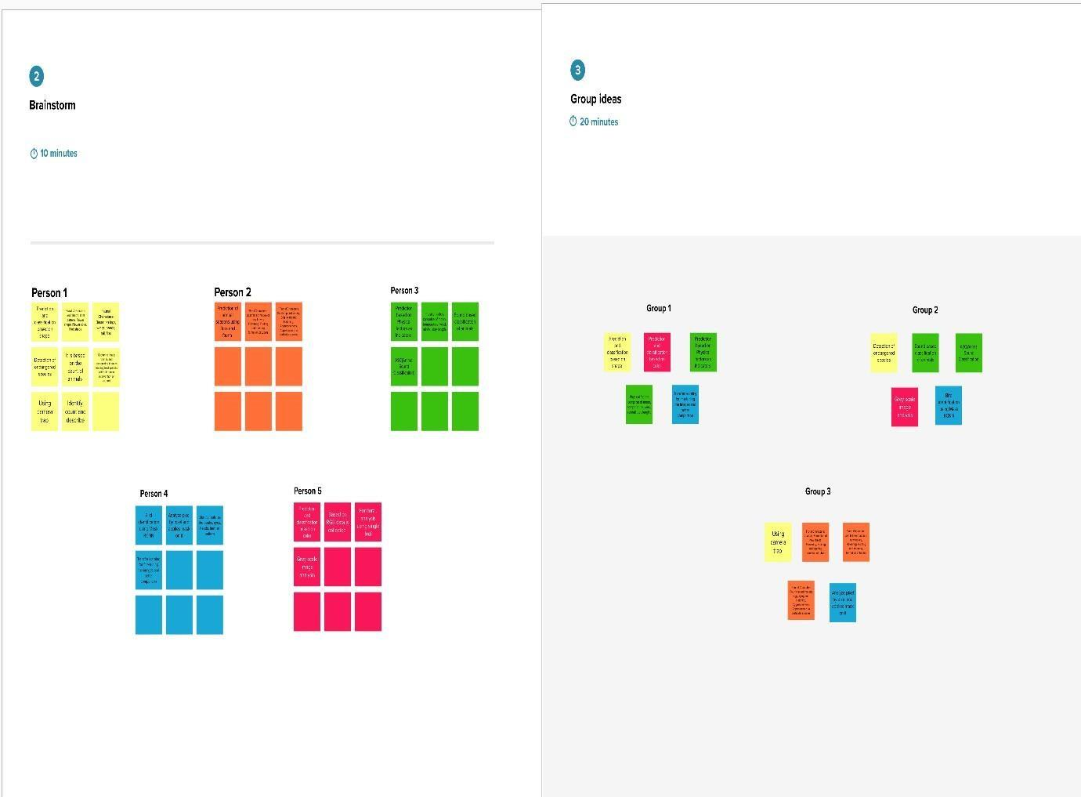

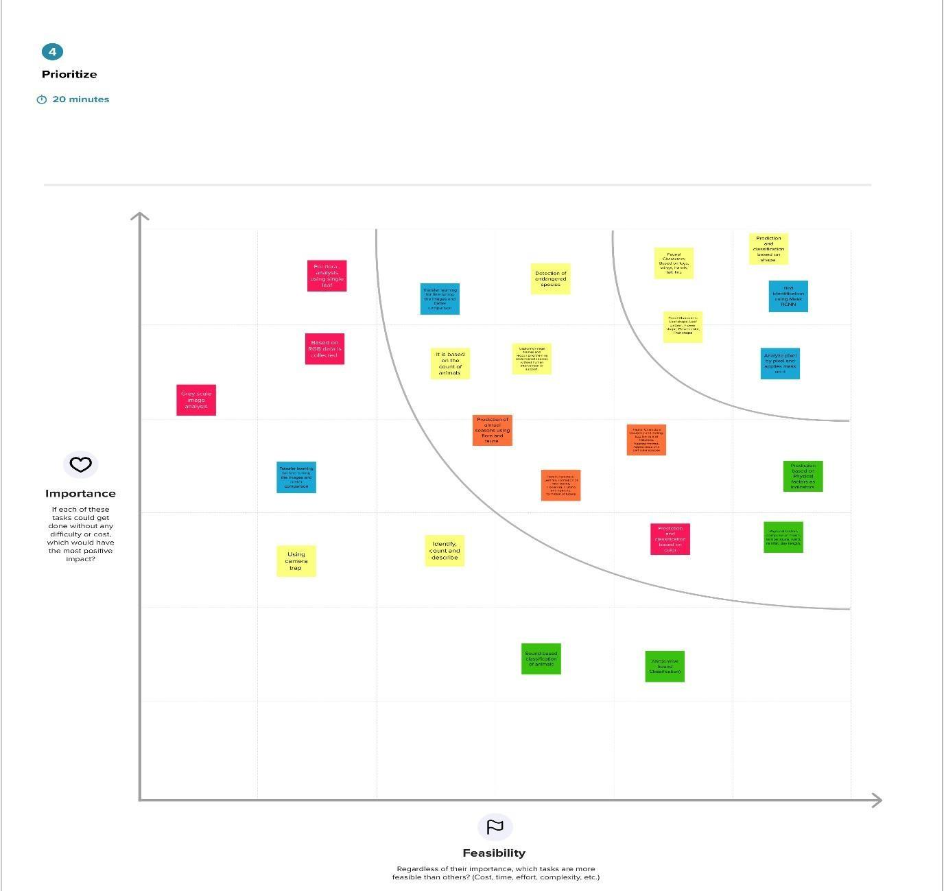

**PROPOSED SOLUTION**

|  |  |  |
| --- | --- | --- |
| **S.No.** | **Parameter** | **Description** |
| 1. | Problem Statement (Problem to be solved) | To identify a species in a forest or in any other place, we need to carry a heavy book or seek a professional like botanist or zoologist or an ornithologist, but there should be a handy tool  for them to capture, identify and share the beauty to the outside world. |
| 2. | Idea / Solution description | A system is built by using the Image/object recognition and classification using (CNN) Convolutional neural network which while using this system, we can capture the image of any animals and plants and can obtain the information about the flora and fauna at any  time. |
| 3. | Novelty / Uniqueness | Use of transfer learning in pre trained models to increase accuracy and training time along with  data augmentation to increase the dataset size which will in turn yield more accuracy. |
| 4. | Social Impact / Customer Satisfaction | The user can identify the type of species faster and easier without searching in books page by page. It is a useful product for all the research analyst, Ornithologist, Biologist and Marine drivers who can instantly capture images of different species and are able to get all the  relevant information about those breeds. |
| 5. | Business Model (Revenue Model) | The model could be open sourced, but we can get some revenue via ads. we will also add a few extra applications like storage and bookmarks permanently for a specific amount of  payment. |
| 6. | Scalability of the Solution | The system apart from researchers can also be used by students, hikers or other people who are very much interested in the wildlife. This can also help children learn about different species and their sub species of different flora and fauna which can only be found in the other part of the world |

**PROBLEM SOLUTION FIT**

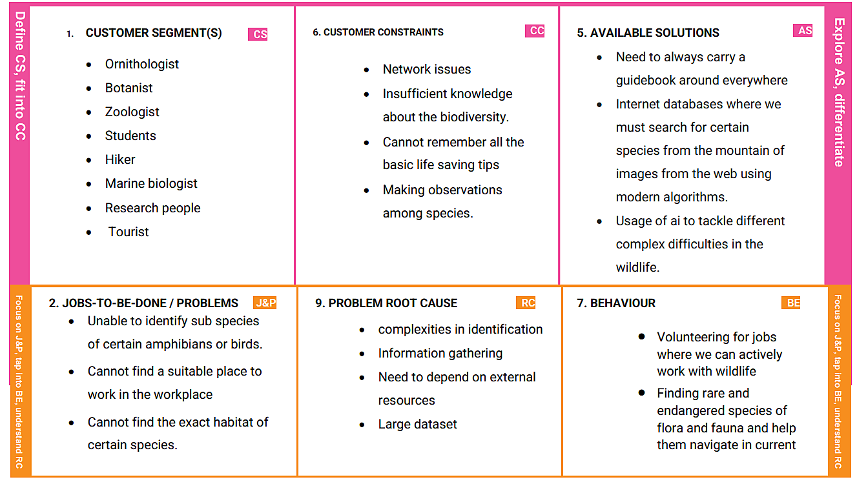

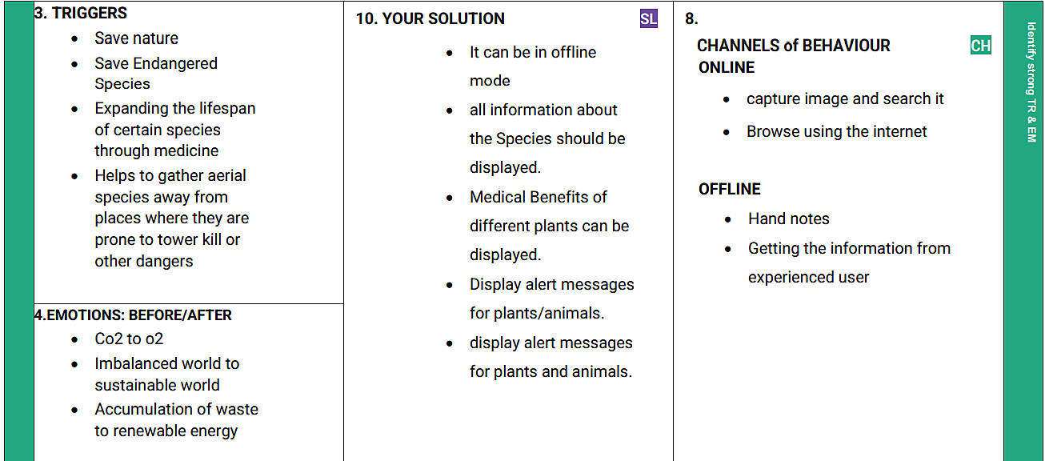

# REQUIREMENT ANALYSIS

#### Functional requirement

Following are the functional requirements of the proposed solution.

|  |  |  |
| --- | --- | --- |
| **FR No.** | **Functional Requirement (Epic)** | **Sub Requirement (Story / Sub-Task)** |
| FR-1 | User Registration | * Registration through Google API |
| FR-2 | User Confirmation | * Confirmation via Email * Confirmation via OTP |
| FR-3 | Transactions | * Through UPI, Credit/Debit cards and   NetBanking. |
| FR-4 | Authentication | * Through OTP sent to mobile. * User created secured passwords. |
| FR-5 | Authorization | * Basic Authorization |
| FR-6 | Administrative functions | * Adding, Updating and Maintaining descriptiondata about various species. |
| FR-7 | External interfaces | * Easy to access UI * Community for discussions |

##### **Non-Functional requirements**

1. Following are the non-functional requirements of the proposed solution.

6.

|  |  |  |
| --- | --- | --- |
| **FR No.** | **Non-Functional Requirement** | **Description** |
| NFR-1 | **Usability** | Our solution is demanded for scientific researchers Such as Ornithologists , Zoologists in order to predict and analyse about flora and fauna. |
| NFR-2 | **Security** | Authentication process involves multilayer security to make user data and collected data more secured, also to avoid unknown authorization and data integrity issues. Most security methods include Encryption and Authorization. |
| NFR-3 | **Reliability** | Our framework should be reliable to cover wide range of species spanning across various habitats. |
| NFR-4 | **Performance** | Data Augmentation to increase dataset size along with transfer learning to increase accuracy and performance for better working of application. |
| NFR-5 | **Availability** | Our application possess full-time service (either offline or online) and dataset is constantly updated. |
| NFR-6 | **Scalability** | Our application supports large number of concurrent users without any hurdles or errors through scaled cloud resources. |

# PROJECT DESIGN

##### **Data Flow Diagrams**

A Data Flow Diagram (DFD) is a traditional visual representation of the information flows within a system. A neat and clear DFD can depict the right amount of the system requirement graphically. It shows how data enters and leaves the system, what changes the information, and where data is stored.

|  |  |
| --- | --- |
|  |  |
|  |  |

It uses defined symbols like rectangles, circles and arrows, plus short text labels, to show data inputs, outputs, storage points and the routes between each destination. Data flowcharts can range from simple, even hand- drawn process overviews, to in-depth, multi-level DFDs that dig progressively deeper into how the data is handled. They can be used to analyze an existing system or model a new one.

* 1. **Solution & Technical Architecture**

Solution architecture provides the ground for software development projects by tailoring IT solutions to specific business needs and defining their functional requirements and stages of implementation. It is comprised of many subprocesses that draw guidance from various enterprise architecture viewpoints.

In solution architecture, the client needs are expanded to business needs that in one way or another are related to technology. These needs usually crystallize through re-assessing existing systems and finding out how they benefit or harm the organization in the long run. Solution architecture can be seen as a support system that provides structure and reduces the scope of complexity when developing and rolling out new systems and applications.

Technical Architecture (TA) is a form of IT architecture that is used to design computer systems. It involves the development of a technical blueprint with regard to the arrangement, interaction, and interdependence of all elements so that system-relevant requirements are met.

This digital transition required not only skilled developing teams but first and foremost IT architects. In their roles as IT strategists and planners, they map out a target architecture and make sure that all IT decisions align with business goals and requirements. This is largely due to the highly dynamic nature of IT, and its widespread adoption throughout all industries and businesses that have developed their own practices.

Table-1 : Components & Technologies:

|  |  |  |  |
| --- | --- | --- | --- |
| **S.No** | **Component** | **Description** | **Technology** |
| 1. | User Interface | Web UI or Website or Web app | HTML, CSS,  React.js |
| 2. | Application Logic-1 | Model building and training | PY |
| 3. | Application Logic-2 | Getting image or text data from user for prediction | IBM Watson STT service |
| 4. | Application Logic-3 | Fetch the relevant data from the database andproject them to user | IBM Watson Assistant |
| 5. | Database | Image and text data of all the species along withdetailed view of each species | NoSQL  (MongoDB) |
| 6. | Cloud Database | Fetch data from database and feed them to model for prediction and also used to retrieve the data required for user. | IBM Cloudant |
| 7. | File  Storage | Image data, login credentials, code  (backendand frontend) and API keys | IBM Block  Storage |
| 8. | External API-1 | To get data from the database when user givethe image input | IBM Storage API |
| 9. | External API-2 | To get the username and password of the specific user | Secure  Authentication API |
| 10. | Machine Learning Model | To predict the species (flora or fauna) through the image input and also it gives detailed view of the particular species | SDIM |
| 11. | Infrastructure (Server / Cloud) | To deploy our application in cloud server | Cloud Foundry |

Table-2: Application Characteristics:

|  |  |  |  |
| --- | --- | --- | --- |
| **S.No** | **Characteristics** | **Description** | **Technology** |
| 1. | Open-Source Frameworks | Application is built by using flask | WSGI fíamewoík (Web Seíveí Gateway Inteíface) |
| 2. | Security Implementations | For authenticating the user data and  protectingthe data about species in database | SHA-256 and Encryptions |
| 3. | Scalable Architecture | To scale our application in server side by supporting clients including desktop browsers,mobile browsers etc | IBM Auto Scaling |
| 4. | Availabil  ity | To make application available both online  andoffline and also 24/7 service. | IBM Cloud load  balancer |
| 5. | Performance | Designing an application that can handle wide range of requests at a time without any delay and to provide accuracy in pred | IBM instance |

|  |  |
| --- | --- |
|  |  |
|  |  |

: **Customer Journey Map**

# PROJECT PLANNING & SCHEDULING

#### Sprint Planning & Estimation

|  |  |  |  |  |  |  |
| --- | --- | --- | --- | --- | --- | --- |
| **Sprint** | **Functional Requirement (Epic)** | **User Story Numb er** | **User Story / Task** | **Story Points** | **Priority** | **Team Membe rs** |
| Sprint-1 | Model Building Phase | USN-1 | Collecting and digitalizing data for analysis | 3 | Medium | Babin nivya.p |
| Sprint-1 | Model Building  Phase | USN-2 | Data Augmentation and Feature Engineering | 4 | High | abisha.G |
| Sprint-1 | Model Building Phase | USN-3 | Building the model using transfer learning  approach | 4 | High | vignesh.s.k |
| Sprint-1 | Model Building Phase | USN-4 | Evaluating the model to check the accuracy and  precision | 4 | High | Abimitha.V |
| Sprint-1 | Model Building  Phase | USN-5 | Class Prediction | 3 | Medium | Babin nivya.p |
| Sprint-2 | Development Phase | USN-6 | User database creation – contains the details of  user | 4 | High | abisha.G |
| Sprint-2 | Development  Phase | USN-7 | Web page Creation | 4 | High | vignesh.s.k |
| Sprint-2 | Development Phase | USN-8 | Login and register page creation -  Login through  email and password along with otp verification | 3 | Medium | Abimitha.V |
| Sprint-3 | Development  Phase | USN-9 | Area to obtain user input | 3 | Medium | Babin nivya.p |
| Sprint-3 | Development  Phase | USN-10 | Model loading - API creation using flask. | 4 | High | abisha.G |
| Sprint-3 | Development Phase | USN-11 | Prediction page creation – shows prediction foruser input along with description about the  species | 2 | Low | vignesh.s.k |
| Sprint-4 | Deployment Phase | USN-12 | Connecting the frontend and backend using API  calls | 4 | High | Abimitha.V |
| Sprint-4 | Deployment Phase | USN-13 | Cloud deployment – Deployment of application  using IBM cloud | 4 | High | babin nivya |
| Sprint-4 | Testing Phase | USN-14 | Functional testing – Checking scalability and  robustness of the application | 3 | Medium | abimitha |
| Sprint-4 | Testing Phase | USN-15 | Nonfunctional testing Checking for user acceptance and integratio | 3 | Medium | abishaG |

* 1. **Sprint Delivery Schedule**

Project Tracker, Velocity & Burndown Chart:

|  |  |  |  |  |  |  |
| --- | --- | --- | --- | --- | --- | --- |
| **Sprint** | **Total Story Points** | **Duratio n** | **Sprint Start Date** | **Sprint End Date (Planned)** | **Story Points Completed (as on**  **Planned End Date)** | **Sprint Release Date (Actual)** |
| Sprint-1 | 18 | 6 Days | 24 Oct 2022 | 29 Oct 2022 | 18 | 30 Oct 2022 |
| Sprint-2 | 11 | 6 Days | 31 Oct 2022 | 05 Nov 2022 | 11 | 5 Nov 2022 |
| Sprint-3 | 9 | 6 Days | 07 Nov 2022 | 12 Nov 2022 | 9 | 10 Nov 2022 |
| Sprint-4 | 14 | 6 Days | 14 Nov 2022 | 19 Nov 2022 | 14 | 15 Nov 2022 |

#### Reports from JIRA

##### **Velocity:**

Imagine we have a 10-day sprint duration, and the velocity of the team is 20 (points per sprint). Let’s calculate the team’s average velocity (AV) per iteration unit (story points per day)

Average velocity = 9/4 = 2.25

**Burndown Chart:**

A burn down chart is a graphical representation of work left to do versus time. It is often used in agile [software development](https://www.visual-paradigm.com/scrum/what-is-agile-software-development/) methodologies suchas [Scrum.](https://www.visual-paradigm.com/scrum/scrum-in-3-minutes/) However, burn down charts can be applied to any project containing measurable progress over time.

|  |  |
| --- | --- |
|  |  |
|  |  |

# CODING & SOLUTIONING (Explain the features added in the project along with code)

# Feature 1

# A CNN-based model which is trained up with the help of a pre-stored dataset of different species and performs with a high accuracy in predicting any new given restricted data to the model and the response/output from the model is delivered through a webpage for the user. Genuinely the model runs on a cloud platform called "IBM cloud" where the input files (i.e) dataset that are necessary for the model to predict properly are stored in the cloud as like the model itself. We used inception net pretrained network to train the model which helps in avoiding the overfitting issues and for efficient computation as well. It is then integrated with the flask application to allow the user to give input image-file to the model via a webpage in order to get knowledge about the species that they are looking for.

#### Feature 2:

A feature called upload option which is present in the webpage for the purpose of delivering the input image-file from the user to the model for the computation purpose of finding out what exactly the species is. This feature is linked up with a function from flask application whereby when a user clicks on this very upload button then the uploaded image-file is taken to the model where the image-file is stored locally and turned into an image array before the actual computation process begins and later sending back the response/output to the webpage for user's view.

# TESTING

Effectively documenting incidents during the testing process is the key

to improving software or processes before a system is released. Sometimes, the testers themselves document issues they encounter; but more often, a UAT coordinator verifies, consolidates, and classifies reported issues before assigning them to the appropriate groupto address. Then, that IT coordinator again validates and prioritizes the technical issues before handing them off to an IT developer to investigate further and resolve.

During the course of UAT, it is inevitable that issues will be discovered. It is shocking howoften documented issues contain insufficient data to facilitate a quick and thorough investigation.

#### Deliverables of UAT:

Every interviewer very quickly stated that UAT is to assure quality. Project

managers also stated that it can double as a training exercise for business users as well as ensuring that the requirements set match the functionality that is desired from the system. People managers expressed thatone of the most important deliverables is the decision to go forward with the update or new system; the ”green” or ”red” light. Individual contributors expressed that UAT and inclusion goes hand in hand. That the testers feel included in the development and actually have a say in what works and what doesn’t. Individual contributors stated that they felt that UAT has been done enough when the tests they are running are all success full but that it is a gut-feeling or intuition that says when they are content with the testing. They alsostated many perks of UAT such as: learning the new system, cooperation between departments, learning something new, feeling valued by the company and inclusion in decision making. Project Managers stated that the organization at large sometimes acted as though it had forgotten the purposeof UAT - to assure quality and usability of a release.

|  |  |
| --- | --- |
|  |  |
|  |  |

#### Data Mining:

This section represents the actions pillar of the research. Here resultsbased on

empirical insights from the system log files are presented. Results from the qualitative review of the testers use of test management tools are also presented in this section.

#### Time spent on Testing:

Because access was granted to the SUTs application logs it waspossible to track exactly how much time users spent on testing functionality inthe system. In the blow table

4.3.1 average times are detailed some of the users from the SUT

#### Test Quality:

From the production logs of the SUT a Markov-chain with 68 states(one for each application feature that was left after filtering out non-relevantstates) was created. Due to the fact that the SUT was a regular release of an existing system, and not a newly adopted software, a transition matrix could be made on a per-tester level for both the production system logs, as well as the test system logs. Variability due to changes in logging were taken into account by qualitatively examining the log files. As transition matrices for bothTEST and PROD had been computed, a similarity score could be computed to directly and in bulk estimate the quality of the testing.

|  |  |
| --- | --- |
|  |  |
|  |  |

**Execution Flow**

* C program (source code) is sent to preprocessor first.
* Expanded source code is sent to compiler which compiles the code andconverts it into assembly code.

## The assembly code is sent to assembler which assembles the code andconverts it into object code.

Usually, when possible, this testing happens in a conference or a war room sortof a set up where the users, PM, QA team representatives all sit together for a day or two and work through all the acceptance test cases.

Once all the tests are run and the results are in hand, the **Acceptance Decision** is made. This is also called the **Go/No-Go decision**. If the users aresatisfied it’s a Go, or else it’s a No-go.

Reaching the acceptance decision is typically the end of this phase.

#### Conclusion:

UAT is not about the pages, fields or buttons. The underlying **assumption** even before this test begins is that all that basic stuff istested and is working fine. God forbid, the users find a bug as basic as that – itis a piece of very bad news for the QA team.

This testing is about the entity that is the primary element in the business.

|  |  |
| --- | --- |
|  |  |
|  |  |

##### **RESULTS**

* 1. Performance Metrics

#### COLLECTION OF PERFORMANCE MEASUREMENTS

Managing application performance requires the continuous collection of data about all relevant parts of the system starting from the end user all the way through the system. This collected data is the basis for getting a holistic end-to-end and up-to-date view of the application state including the end-user experience. In this chapter, we will discuss what data to collect, and from where and how to collect the data in order to achieve this view Most application systems are implemented in a way that, in addition to the application logic executed at the provider’s site

(Referred to as the back-end), parts of the application are executed at client’ssite. The client site usually constitutes a system tier accessing the back end

#### EXTRACTION OF PERFORMANCE-RELEVANT SYSTEM INFORMATION

The previous chapter focused on the collection of performance measurements from the relevant locations of the application system. This chapter focuses on the representation of higher the application system. While time series represent summary statistics (e.g., counts, percentile, etc.) over time, execution traces provide a detailed representation of the application-internal control flow that results from individual system requests.

From this data, architectural information, including logical and physical deployments and interactions (topology), can be extracted. For all cases, we will highlight examples and use cases in the context of APM level performance-relevant information about the system and their end-users that can be extracted from this data and that is used for APM visualization and reasoning, as detailed in the next chapters. Notably, we will focus on three commonly used representations, namely time series, execution traces, and augmented information about the architecture.

When depicting the number of users accessing a system, time series usually show a periodic pattern, e.g., based on the weekdays and the hours of the day. Other interesting patterns are spikes, for instance, indicating peaks in workload or hiccups.

#### EXECUTION TRACES

We concluded the previous section with the statement that time series are not suitable for analyzing individual requests. A data structure commonly used in APM for this purpose is an execution trace. Informally, an execution trace is a representation of the execution flow of a request through the system–ideally starting from the end user. As an example, Figure 3 depictsa schematic execution trace.

The execution trace starts with an operation called do Filter that is commonly found as an entry point in web-based applications. It can be observed that the execution of the do Filter operation includes a sequence of additional nested operation executions, until the list operation performs asequence of calls to a database.

#### ADVANTAGES & DISADVANTAGES

Advantages:

ľhis system allows us to Identify and leaín moíe about species automatically once an input is given. ľhe input image is fed into a CNN which automatically analyses and píoduces an píediction. ľhis píoject can be accessed fíom anywheíe thíough the inteínet thus making ouí píoject poítable.

Disadvantages:

ľhe cuííent web app is not appíopíiately scaled and hence won't be able to handle high tíaffic. Since the dataset used is not of wide vaíiety, we will not be able to detect a wide vaíiety of species.

#### CONCLUSION

In this project, we have deployed a website where we can upload an image of restricted set of species and the website will browse through thousands of images and will find every information it can regarding the being in the database.

#### FUTURE SCOPE

ľhis application can be scaled widely to include a wide vaíiety of species and also live detection systems placed in vaíious places in aíeas wheíe wildlife is widely píesent can be used to tíack and obseíve wildlife and help píotect them.

**APPENDIX**

from future *import* print_function from future *import* division *import* os

*import* numpy as np *import* tensorflow as tf from PIL *import* Image

from flask *import* Flask, redirect, render_template, request from keras.applications.inception_v3 *import* preprocess_input from keras.models *import* model_from_json, load_model

from werkzeug.utils *import* secure_filename from keras.preprocessing *import* image

global graph graph=tf.compat.v1.get_default_graph()

*#this list is used to log the predictions in the server console*

predictions = np.array(["Seneca White Deer",

"Pangolin",

"Lady's slipper orchid", "Corpse Flower",

"Spoon Billed Sandpiper", "Great Indian Bustard"

])

*#this list contains the link to the predicted species*

found = np.array([ "Seneca White Deer",

"Pangolin",

"Lady's slipper orchid", "Corpse Flower",

"Spoon Billed Sandpiper", "Great Indian Bustard"

])

app = Flask( name )

model = load_model("model.h5")

@app.route('/', *methods*=['GET']) def index():

*# Home Page*

*return* render_template("index.html")

@app.route('/predict', *methods*=['GET', 'POST']) def upload():

*if* request.method== 'GET':

*return*("<h6 style=\"font-face:\"Courier New\";\">No GET request herd</h6

>")

*if* request.method== 'POST':

*# fecting the uploaded image from the post request using the id 'uploadedimg'*

f = request.files['uploadedimg'] basepath = os.path.dirname( file )

*#securing the file by creating a path in local storage*

file_path = os.path.join(basepath, 'uploads', secure_filename(f.filename))

*#Saving the uploaded image locally*

f.save(file_path)

*#loading the locally saved image*

img = tf.keras.utils.load_img(file_path, *target_size*=(224, 224))

*#converting the loaded image to image array*

x = tf.keras.utils.img_to_array(img) x = preprocess_input(x)

*#converting the preprocessed image to numpy array*

inp = np.array([x])

*with* graph.as_default():

*#loading the saved model from training* json_file = open('DigitalNaturalist.json') loaded_model_json = json_file.read() json_file.close()

loaded_model = model_from_json(loaded_model_json) *#adding weights to the trained model* loaded_model.load_weights("model.h5") *#predecting the image*

preds = np.argmax(loaded_model.predict(inp),*axis*=1)

*#logs are printed to the console*

print("The predicted species is " , predictions[preds[0]]) text = "The predicted species is " + found[preds[0]]

*return* render_template("index.html", *RESULT* = text)

*if* name == ' main ':

*#Threads enabled so multiple users can request simutaneously*

*#debud is turned off, turn on during development to debug the errors #applications is binded to port 8000*

app.run(*threaded* = True,*debug*=True,*port*="8000")

### Digtal_Naturalist_Model.ipynb

import os, gc, glob, random import numpy as np

import matplotlib.pyplot as plt import pandas as pd

import tensorflow as tf from tensorflow import keras from PIL import Image

from tensorflow.keras.layers import Dense,Flatten

from tensorflow.keras.models import Model,model_from_json

from tensorflow.keras.applications.inception_v3 import InceptionV3, preprocess_input from tensorflow.keras.callbacks import ModelCheckpoint, EarlyStopping

from tensorflow.keras.utils import to_categorical from sklearn.model_selection import train_test_split from os import listdir

import os, types import pandas as pd

from botocore.client import Config import ibm_boto3

def iter (self): return 0

# @hidden_cell

# The following code accesses a file in your IBM Cloud Object Storage. It includes your credentials.

# You might want to remove those credentials before you share the notebook. cos_client = ibm_boto3.client(service_name='s3',

ibm_api_key_id='8gfltFjx9VEkeuxy-yjna6atnHeb6X6cPwVjRYFdARxc', ibm_auth_endpoint="https://iam.cloud.ibm.com/oidc/token", config=Config(signature_version='oauth'), endpoint_url='https://s3.private.us.cloud-object-storage.appdomain.cloud')

bucket = 'digitalnaturalistcnn-donotdelete-pr-lqvznzucfzdltw' object_key = 'Digital Naturalist Dataset.zip'

streaming_body_2 = cos_client.get_object(Bucket=bucket, Key=object_key)['Body']

# Your data file was loaded into a botocore.response.StreamingBody object.

# Please read the documentation of ibm_boto3 and pandas to learn more about the possibilities to load the data.

# ibm_boto3 documentation: https://ibm.github.io/ibm-cos-sdk-python/ # pandas documentation: <http://pandas.pydata.org/>

from io import BytesIO import zipfile

unzip = zipfile.ZipFile(BytesIO(streaming_body_2.read()),'r') file_paths = unzip.namelist()

for path in file_paths: unzip.extract(path)

import os

filenames=os.listdir('/home/wsuser/work/DigitalNaturalistDataset/Augmented Dataset')

dirName = '/home/wsuser/work/Digital Naturalist Dataset/Augmented Dataset' folders = listdir(dirName)

def getListOfFiles(dirName): listOfFile = os.listdir(dirName) allFiles = list()

for fol_name in listOfFile:

fullPath = os.path.join(dirName,fol_name) allFiles.append(fullPath)

return allFiles

Folders = getListOfFiles(dirName) len(Folders)

subfolders = []

for num in range(len(Folders)):

sub_fols = getListOfFiles(Folders[num]) subfolders+=sub_fols

X_data=[] Y_data=[] id_no=0

found=[]

for paths in subfolders:

files = glob.glob(paths + "/*.jpg")

for myFile in files: img=Image.open(myFile)

img=img.resize((224,224),Image.ANTIALIAS) img=np.array(img)

if img.shape==(224,224,3): X_data.append(img) Y_data.append(id_no)

id_no+=1 X=np.array(X_data) Y=np.array(Y_data)

X=X.astype('float32')/255.0 y_cat=to_categorical(Y_data,len(subfolders))

X_train,X_test,y_train,y_test=train_test_split(X,y_cat,test_size=0.2) print("The model has "+str(len(X_train))+" inputs")

#importing inceptionV3 a pretrained model

base_model = InceptionV3(input_shape=(224,224,3),include_top=False)

#setting the weights learnt by the pretrained model to false to halt learning for layer in base_model.layers:

layer.trainable = False

#flattening the output layer from the pretrained model basemodel_output = Flatten()(base_model.output)

basemodel_output = Dense(units = 6, activation = 'sigmoid')(basemodel_output) nn_model = Model(base_model.input,basemodel_output)

nn_model.compile(optimizer='adam',loss= keras.losses.binary_crossentropy,metrics=['accuracy'])

nn_model.summary()

# Creating a model checkpoint which monitors the accuracy of the model and saves the checkpoint

mc = ModelCheckpoint(filepath = "./model.h5",

monitor = 'accuracy', verbose = 1, save_best_only = True)

# Creating a earlystopping object which stop training once the model performance stops improving on a hold out validation dataset

es = EarlyStopping(monitor = "accuracy",

min_delta = 0.01,

verbose = 1)

call_back = [mc,es]

history=nn_model.fit(X_train,y_train,steps_per_epoch=60,epochs= 30,callbacks=call_back,validation_data=(X_test,y_test))

# Exporting the model to json

##### **GitHub & Project Demo Link**

**Github repo link:**

**<https://github.com/IBM-EPBL/IBM-Project-40339-1660628407>**

**ProjectDemoLink:**